GREATER EL BETHEL MISSIONARY BAPTIST CHURCH
Pastoral Application

PERSONAL INFORMATION

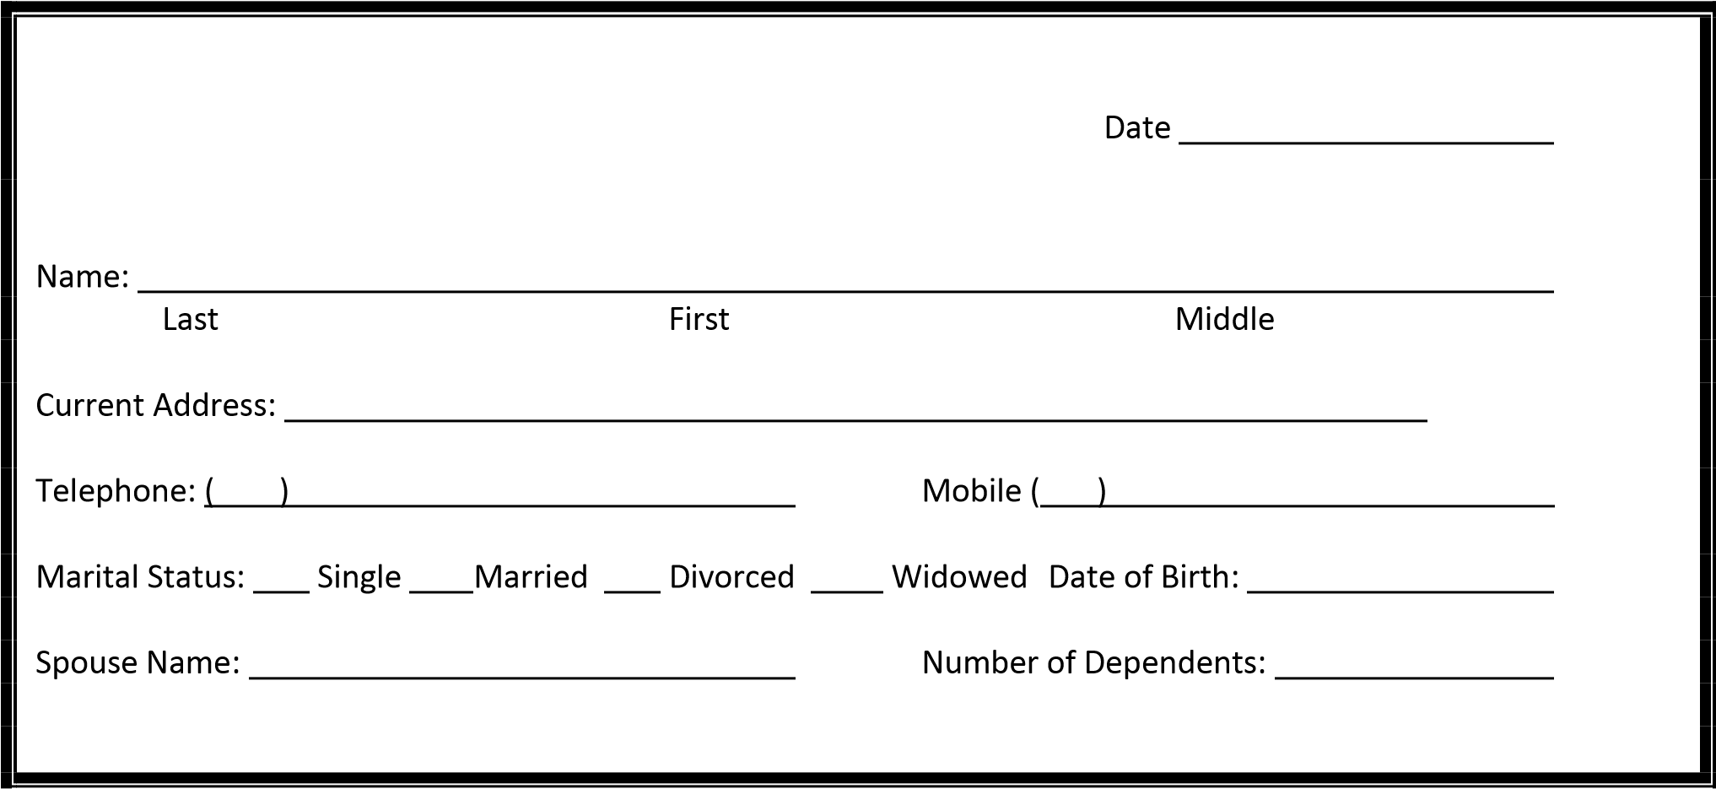

You may use additional sheets of paper at any time

Pastoral Experience:

Church Name:

Address:

Telephone: ( ) Duration

Other Ministerial Experience: (please describe)

Church Name:

Address:

Telephone: ( ) Duration

Your Church Membership if different from church named above:

Church Name:

Address:

Telephone: ( ) Duration

Briefly discuss your call to the ministry:

List your Spiritual Gifts, and tell us how GOD has used them in your ministry:

Describe your Doctrine:

Briefly state your Philosophy on the Ministries of the church:

What do you consider a successful Pastor?

Describe your Leadership Style:

Please describe how you have handled a situation in the past where you disagreed with church leadership or church members:

What method(s) of teaching do you use?

Please evaluate your people skills:

EMPLOYMENT

Are you currently employed? If so, please complete the following.

Name of Employer: ____________________________  Address: _____________________________________  City __________________ State ______ Zip_____________ | Supervisor/Telephone #  _____________________  Position/Title
How long on job? | Date Hired

PREVIOUS EMPLOYMENT(s) within last 5 years
Use separate sheet if necessary

Name of Employer: ____________________________  Address: _____________________________________  City __________________ State ______ Zip_____________ | Supervisor/Telephone #  _____________________  Position/Title
Reason for leaving (be specific | Duration?

EDUCATION
TYPE OF SCHOOL | NAME OF SCHOOL | LOCATION | YEARS  COMPLETED | MAJOR & DEGREE
High School

College

Business/Trade

Theological

